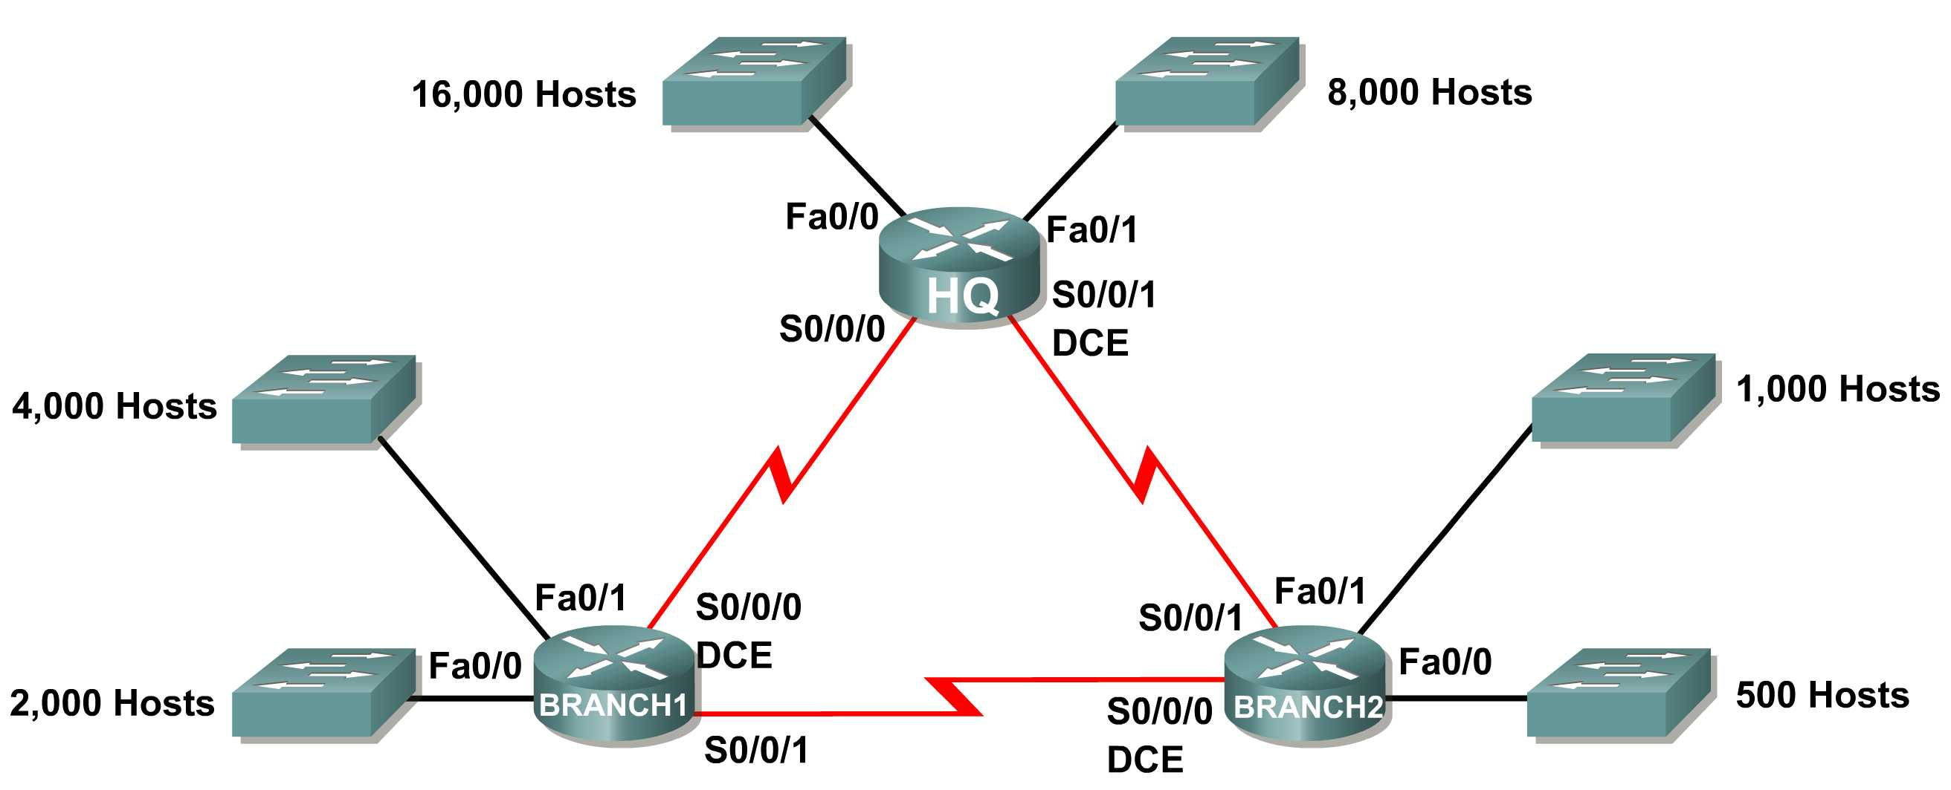
Subnet | Number of IP Addresses Needed | Network Address
HQ LAN1 | 16,000 | 172.16.128.0 /18
HQ LAN2 | 8,000 | 172.16.192.0 /19
Branch1 LAN1 | 4,000 | 172.16.224.0 /20
Branch1 LAN2 | 2,000 | 172.16.240.0 /21
Branch2 LAN1 | 1,000 | 172.16.248.0 /22
Branch2 LAN2 | 500 | 172.16.252.0 /23
Link from HQ to Branch1 | 2 | 172.16.254.0 /30
Link from HQ to Branch2 | 2 | 172.16.254.4 /30
Link from Branch1 to Branch2 | 2 | 172.16.254.8 /30

Device | Interface | IP Address | Subnet Mask | Default Gateway
HQ | S0/0/0 | 172.16.254.1 /30 | 255.255.255.252 | N/A
 | S0/0/1 | 172.16.254.5 /30 | 255.255.255.252 | N/A
 | Fa0/0 | 172.16.128.1 /18 | 255.255.192.0 | N/A
 | Fa0/1 | 172.16.192.1 /19 | 255.255.224.0 | N/A
B1 | S0/0/0 | 172.16.254.2 /30 | 255.255.255.252 | N/A
 | S0/0/1 | 172.16.254.9 /30 | 255.255.255.252 | N/A
 | Fa0/0 | 172.16.240.1 /21 | 255.255.248.0 | N/A
 | Fa0/1 | 172.16.224.1 /20 | 255.255.240.0 | N/A
B2 | S0/0/0 | 172.16.254.10 /30 | 255.255.255.252 | N/A
 | S0/0/1 | 172.16.254.6 /30 | 255.255.255.252 | N/A
 | Fa0/0 | 172.16.252.1 /23 | 255.255.254.0 | N/A
 | Fa0/1 | 172.16.248.1 /22 | 255.255.252.0 | N/A

Scenario
In this activity, the network address 172.16.128.0/17 has been used to provide the IP addressing for the network shown in the Topology Diagram. VLSM has been used to subnet the address space incorrectly. You will need to troubleshoot the addressing that has been assigned for each subnet to determine where errors are present and then determine the correct addressing assignments, where needed.
Task 1: Examine the Addressing for the HQ LANs.
Step 1: Examine the addressing assignment for the HQ LAN1 subnet and answer the questions below:
- How many IP addresses are needed for the HQ LAN1 subnet? 16.000
- How many IP addresses are available in the currently assigned subnet? 2¹³=8.192
- Will the currently assigned subnet fulfill the size requirement for the HQ LAN1 subnet? no
- If the answer to the previous question is no, propose a new subnet mask that will allow for the correct number of IP addresses. 255.255.192.0 or /18
- Does the subnet overlap with any of the other currently assigned networks? no
- If the answer to the previous question is yes, propose a new subnet mask that will allow for the correct number of IP addresses without overlapping into any other subnets.
Step 2: Examine the addressing assignment for the HQ LAN2 subnet and answer the questions below.
- How many IP addresses are needed for the HQ LAN2 subnet?8.000
- How many IP addresses are available in the currently assigned subnet? 2¹⁴=16384
- Will the currently assigned subnet fulfill the size requirement for the HQ LAN2 subnet?yes
- If the answer to the previous question is no, propose a new subnet mask that will allow for the correct number of IP addresses.
- Does the subnet overlap with any of the other currently assigned networks?yes
- If the answer to the previous question is yes, propose a new subnet mask that will allow for the correct number of IP addresses without overlapping into any other subnets. 255.255.224.0 or /19
Task 2: Examine the Addressing for the Branch1 LANs.
Step 1: Examine the addressing assignment for the Branch1 LAN1 subnet and answer the questions below.
- How many IP addresses are needed for the Branch1 LAN1 subnet?4.000
- How many IP addresses are available in the currently assigned subnet? 4.096-2=4.094 usable
- Will the currently assigned subnet fulfill the size requirement for the Branch1 LAN1 subnet? yes
- If the answer to the previous question is no, propose a new subnet mask that will allow for the correct number of IP addresses.
- Does the subnet overlap with any of the other currently assigned networks?no
- If the answer to the previous question is yes, propose a new subnet mask that will allow for the correct number of IP addresses without overlapping into any other subnets.
Step 2: Examine the addressing assignment for the Branch1 LAN2 and answer the questions below.
- How many IP addresses are needed for the Branch1 LAN2 subnet? 2.000
- How many IP addresses are available in the currently assigned subnet? 2.048-2=2.046
- Will the currently assigned subnet fulfill the size requirement for the Branch1 LAN2 subnet? yes
- If the answer to the previous question is no, propose a new subnet mask that will allow for the correct number of IP addresses.
- Does the subnet overlap with any of the other currently assigned networks?no
- If the answer to the previous question is yes, propose a new network address that will allow for the correct number of IP addresses without overlapping into any other subnets.
Task 3: Examine the Addressing for the Branch2 LANs.
Step 1: Examine the addressing assignment for the Branch2 LAN1 subnet and answer the questions below.
- How many IP addresses are needed for the Branch2 LAN1 subnet? 1.000
- How many IP addresses are available in the currently assigned subnet? 1024-2= 1.022 usable
- Will the currently assigned subnet fulfill the size requirement for the Branch2 LAN1 subnet? no
- If the answer to the previous question is no, propose a new subnet mask that will allow for the correct number of IP addresses.255.255.252.0 or /22
- Does the subnet overlap with any of the other currently assigned networks?no
- If the answer to the previous question is yes, propose a new subnet mask that will allow for the correct number of IP addresses without overlapping into any other subnets.
Step 2: Examine the addressing assignment for the Branch2 LAN2 and answer the questions below.
- How many IP addresses are needed for the Branch2 LAN2 subnet? 500
- How many IP addresses are available in the currently assigned subnet? 512-2=510 usable
- Will the currently assigned subnet fulfill the size requirement for the Branch2 LAN2 subnet? yes
- If the answer to the previous question is no, propose a new subnet mask that will allow for the correct number of IP addresses.
- Does the subnet overlap with any of the other currently assigned networks?no
- If the answer to the previous question is yes, propose a new network address that will allow for the correct number of IP addresses without overlapping into any other subnets.
Task 4: Examine the Addressing for the Links between Routers.
Step 1: Examine the addressing assignment for the link between the HQ and Branch1 routers and answer the questions below.
- How many IP addresses are needed for the link between the HQ and Branch1 routers? 2
- How many IP addresses are available in the currently assigned subnet?4-2=2 usable
- Will the currently assigned subnet fulfill the size requirement for the link between the HQ and Branch1 routers? yes
- If the answer to the previous question is no, propose a new subnet mask that will allow for the correct number of IP addresses.
- Does the subnet overlap with any of the other currently assigned networks?yes
- If the answer to the previous question is yes, propose a new subnet mask that will allow for the correct number of IP addresses without overlapping into any other subnets. 255.255.255.252 or /30
Step 2: Examine the addressing assignment for the link between the HQ and Branch2 routers and answer the questions below.
- How many IP addresses are needed for the link between the HQ and Branch2 routers? 2
- How many IP addresses are available in the currently assigned subnet? 4-2=2 usable
- Will the currently assigned subnet fulfill the size requirement for the link between the HQ and Branch2 routers? yes
- If the answer to the previous question is no, propose a new subnet mask that will allow for the correct number of IP addresses.
- Does the subnet overlap with any of the other currently assigned networks?yes
- If the answer to the previous question is yes, propose a new network address that will allow for the correct number of IP addresses without overlapping into any other subnets. 172.16.154.4
Step 3: Examine the addressing assignment for the link between the Branch1 and Branch2 routers and answer the questions below.
- How many IP addresses are needed for the link between the Branch1 and Branch2 routers? 2
- How many IP addresses are available in the currently assigned subnet? 4-2=2 usable
- Will the currently assigned subnet fulfill the size requirement for the link between the Branch1 and Branch2 routers? yes
- If the answer to the previous question is no, propose a new subnet mask that will allow for the correct number of IP addresses.
- Does the subnet overlap with any of the other currently assigned networks?no
- If the answer to the previous question is yes, propose a new subnet mask that will allow for the correct number of IP addresses without overlapping into any other subnets.

